**Project Day 2**

**TEAM GROUP M**

TEAM MEMBERS:

1. Chinmay Kulkarni (leader)
2. SV Kartikeya
3. Kartik MC
4. Hrithik Roshan

**Google colab link:**

https://colab.research.google.com/drive/1kBz4x7iU1GX0XXEwfiL3IJ2NcguJQdo1#

**Problem Statement 5: (Find and process Missing Data)**

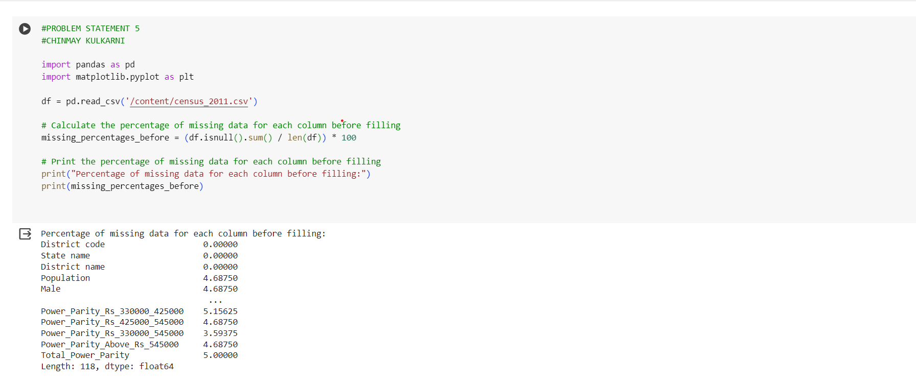

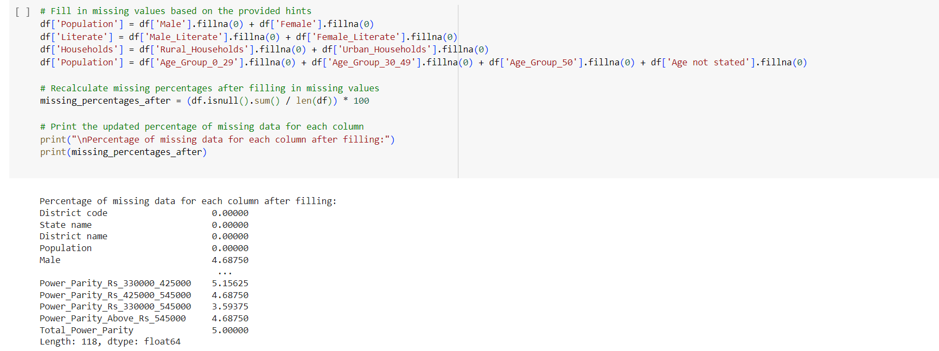

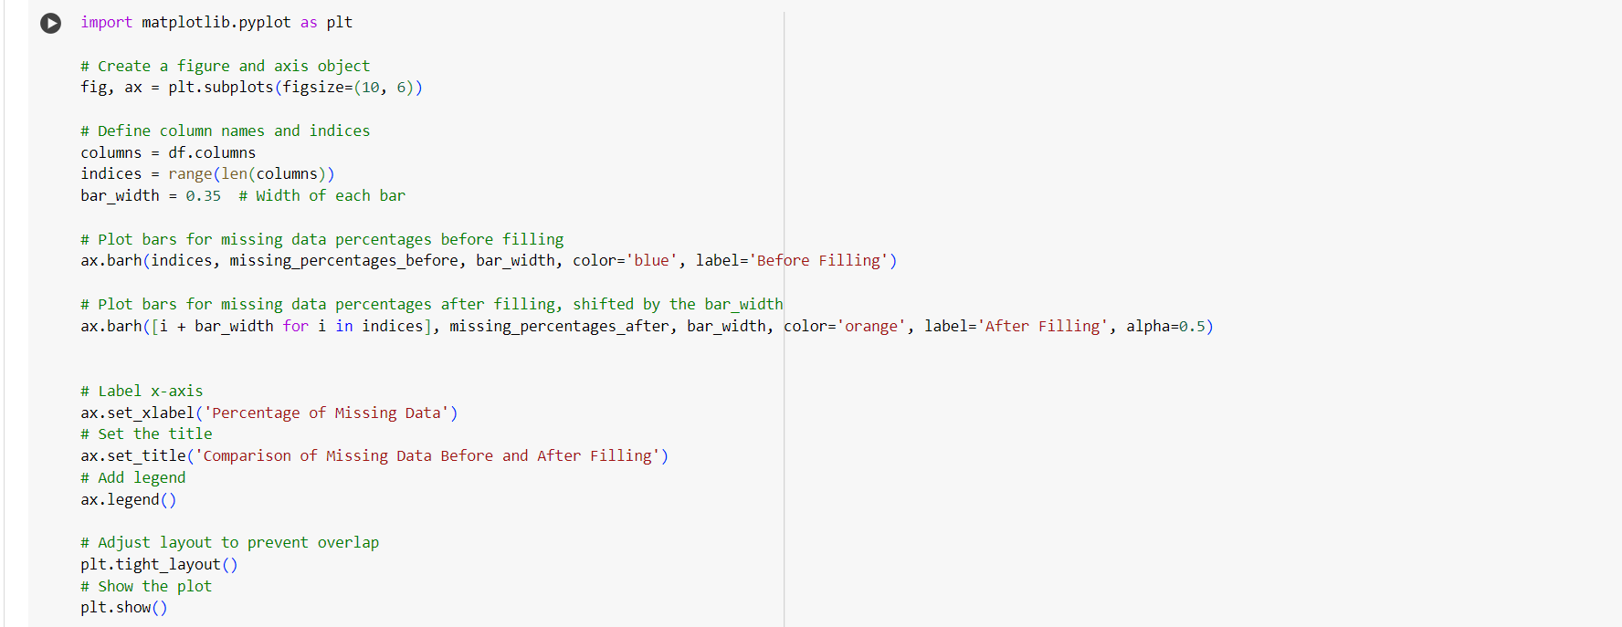

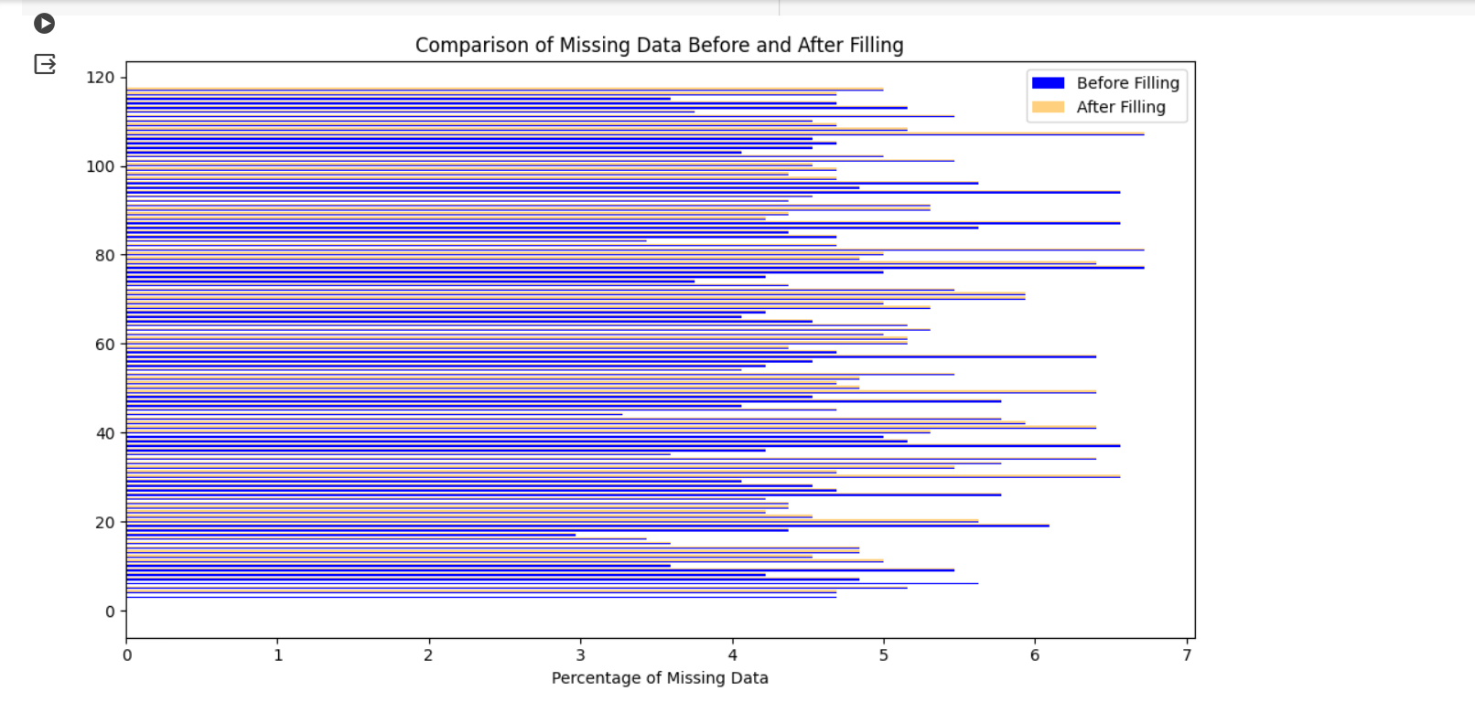

**Problem Statement 6: (Save Data)**

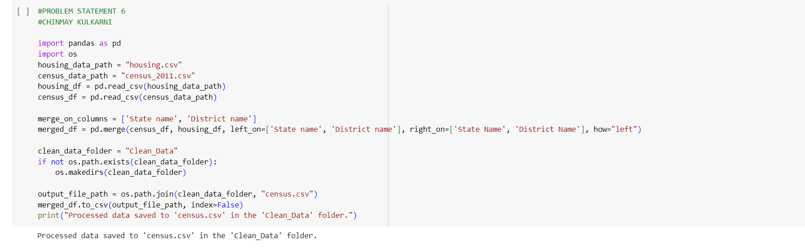

**Problem Statement 7: (Process the relevant data)**

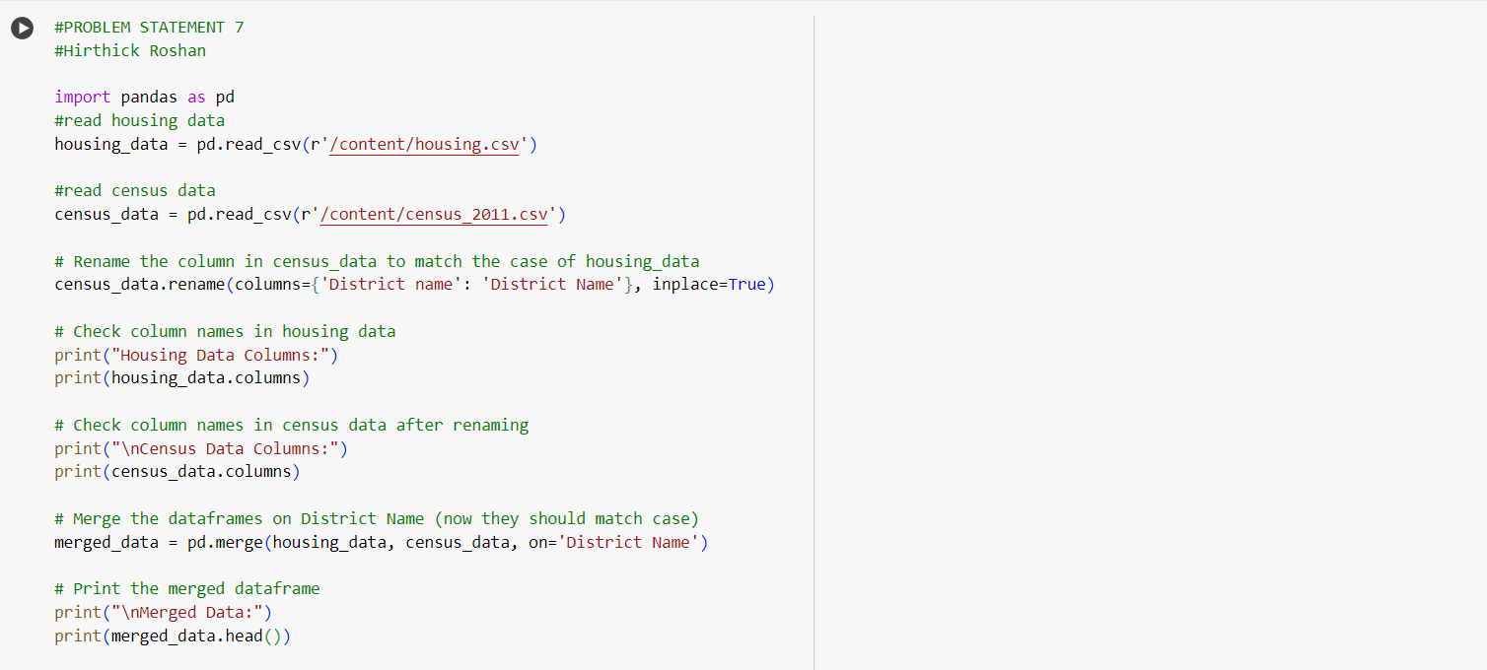

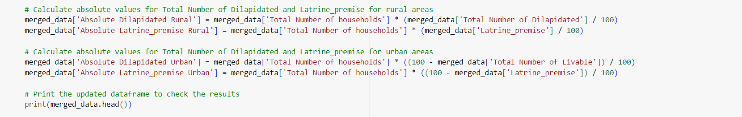

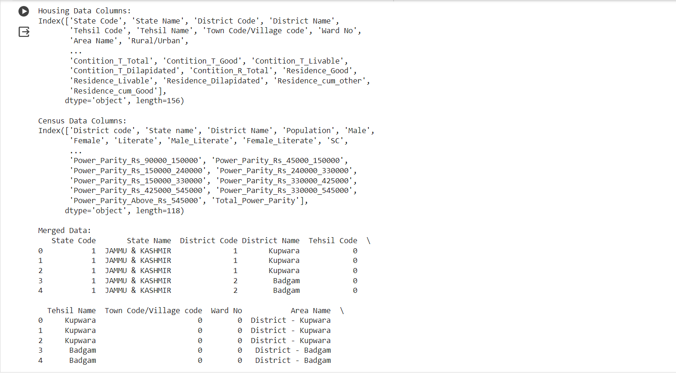

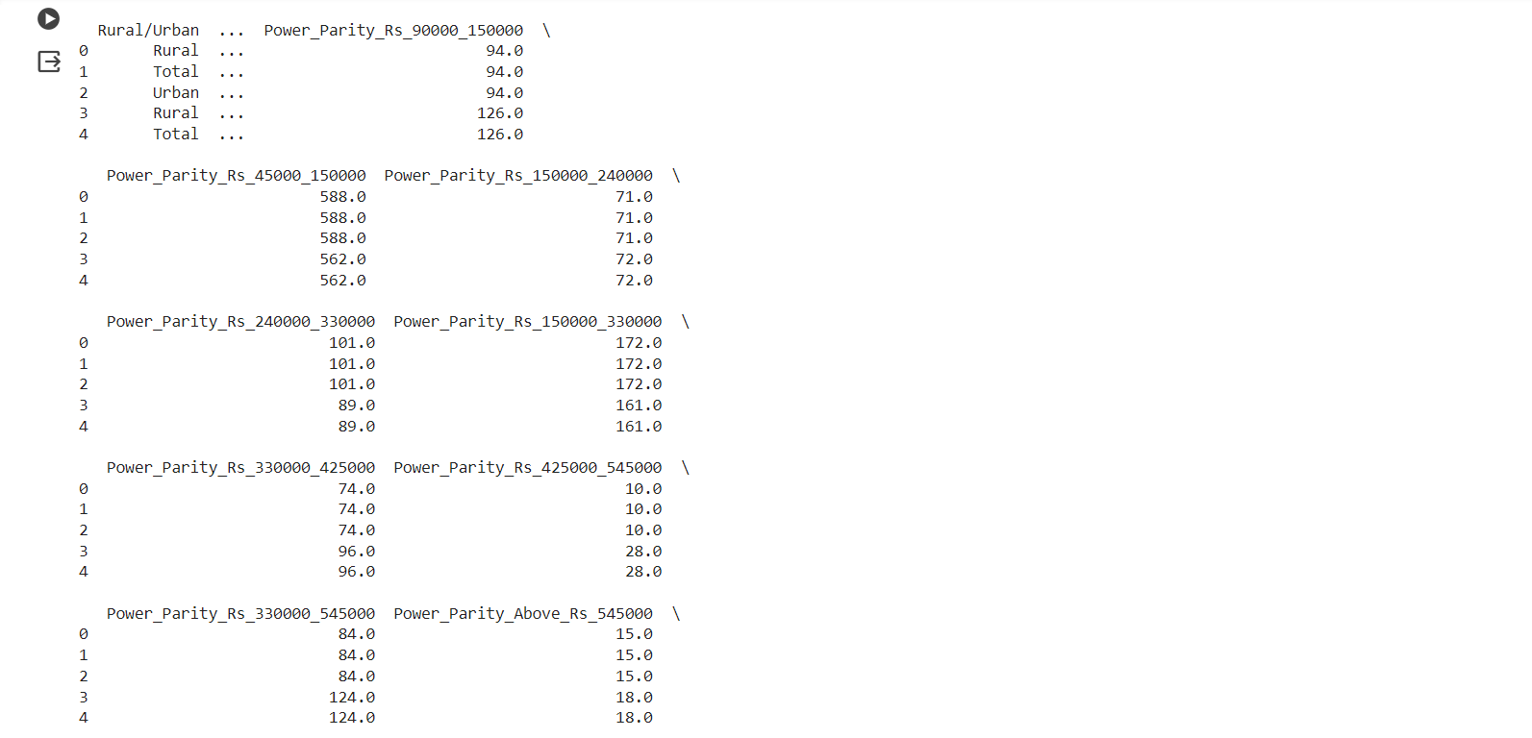

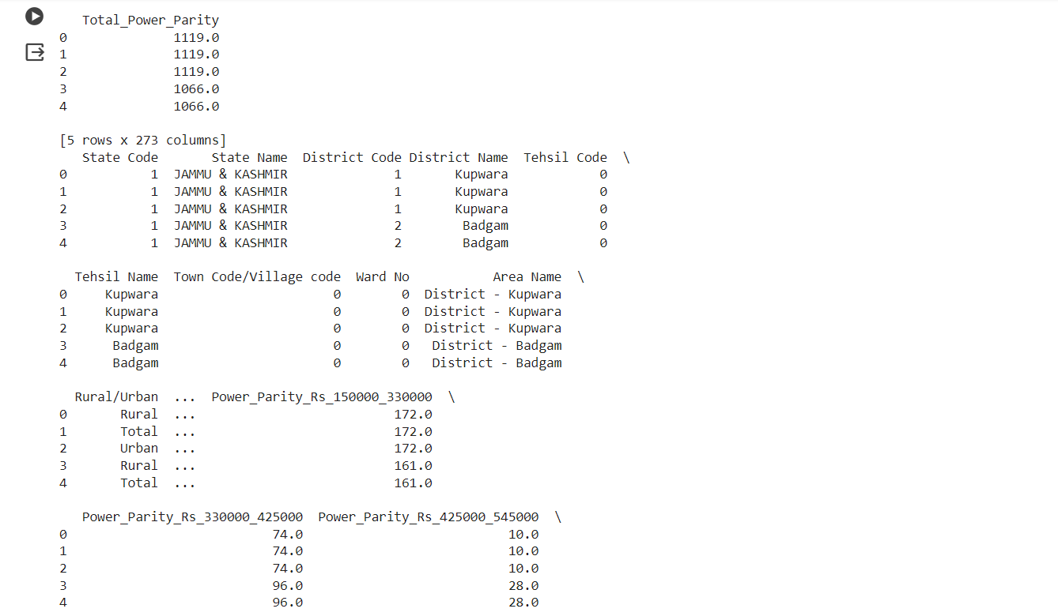

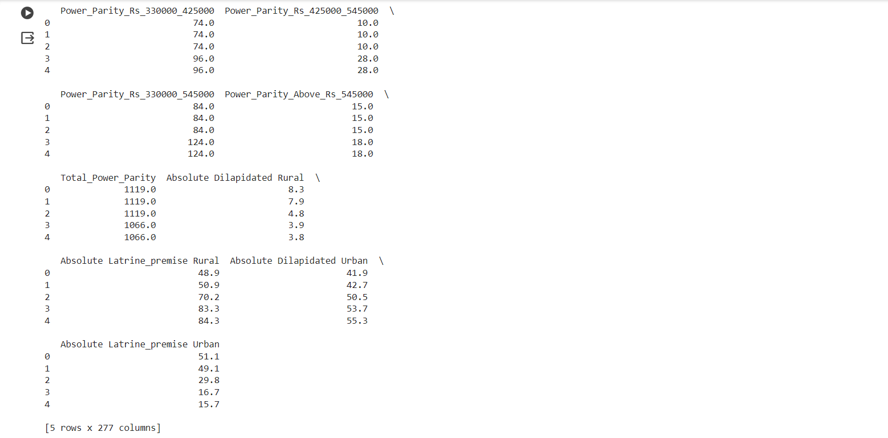

**Problem Statement 8: (Visualise the housing data)**

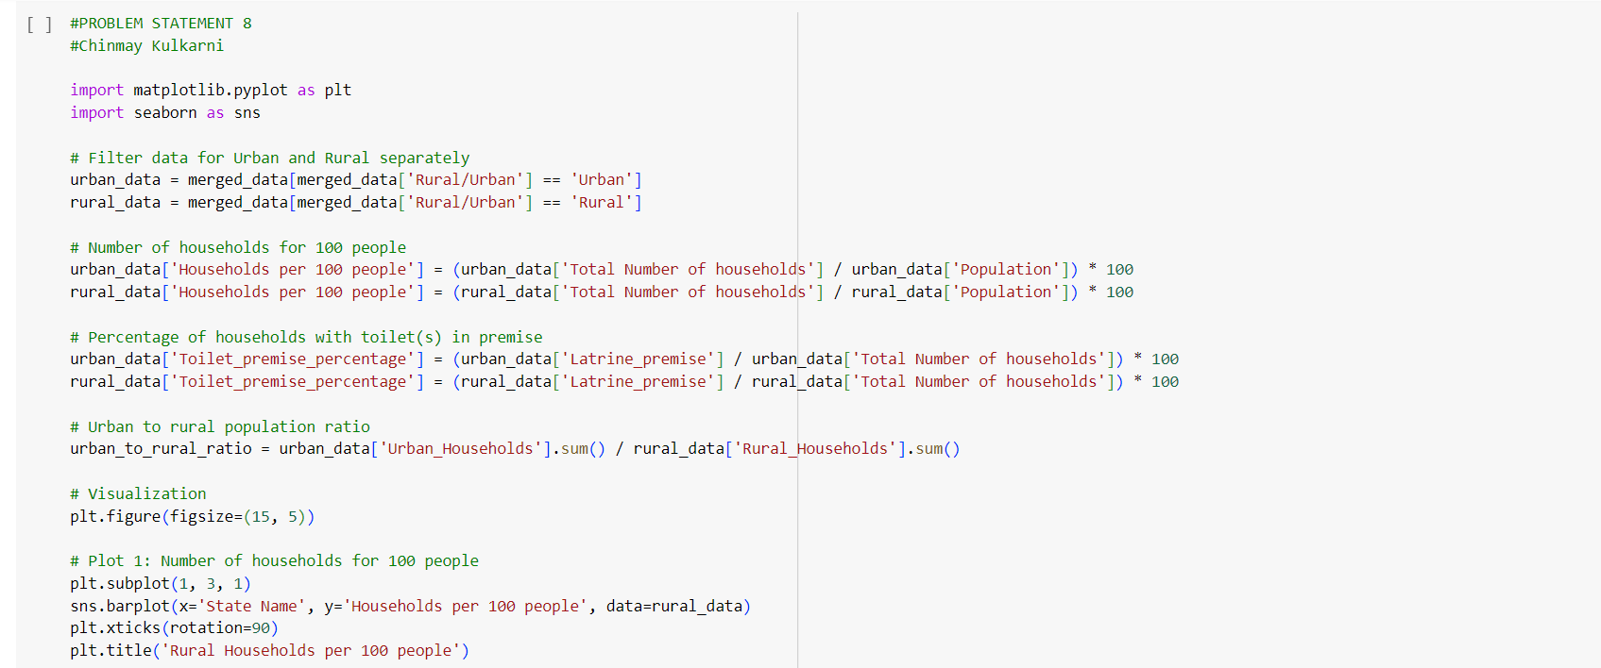

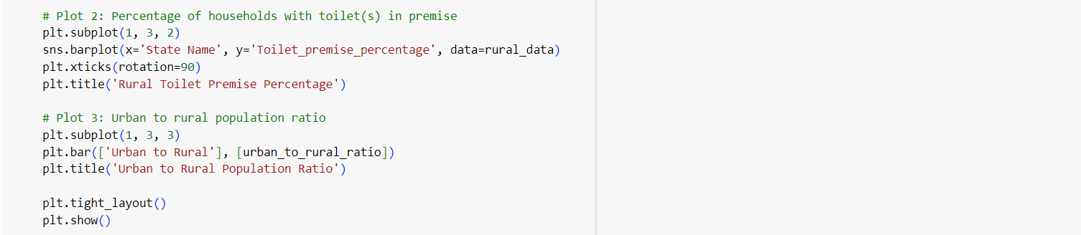

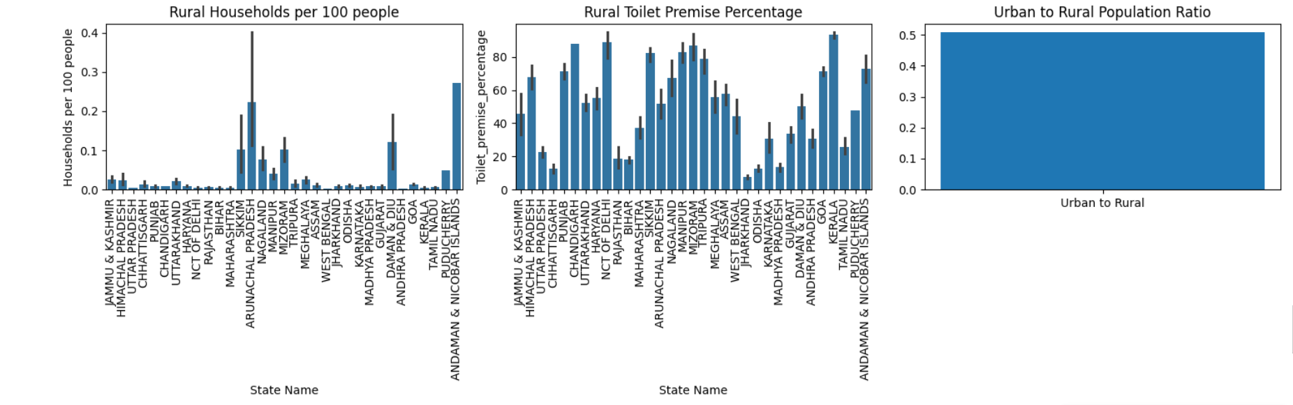

**Problem Statement 9: (Inconsistency in different datasets)**

